1.On week1, we had formed our own group and defined our goals clearly and let everyone on the team know "make sure you establish consistent goals and keep them clear"

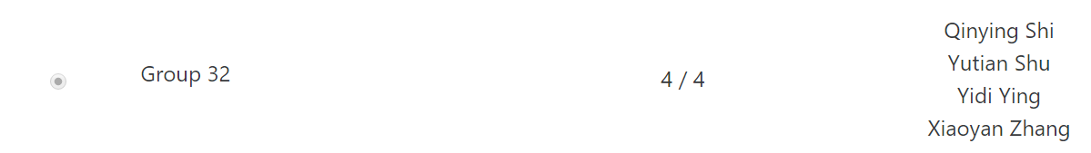

We had got started with git and record a Stakeholder Register.

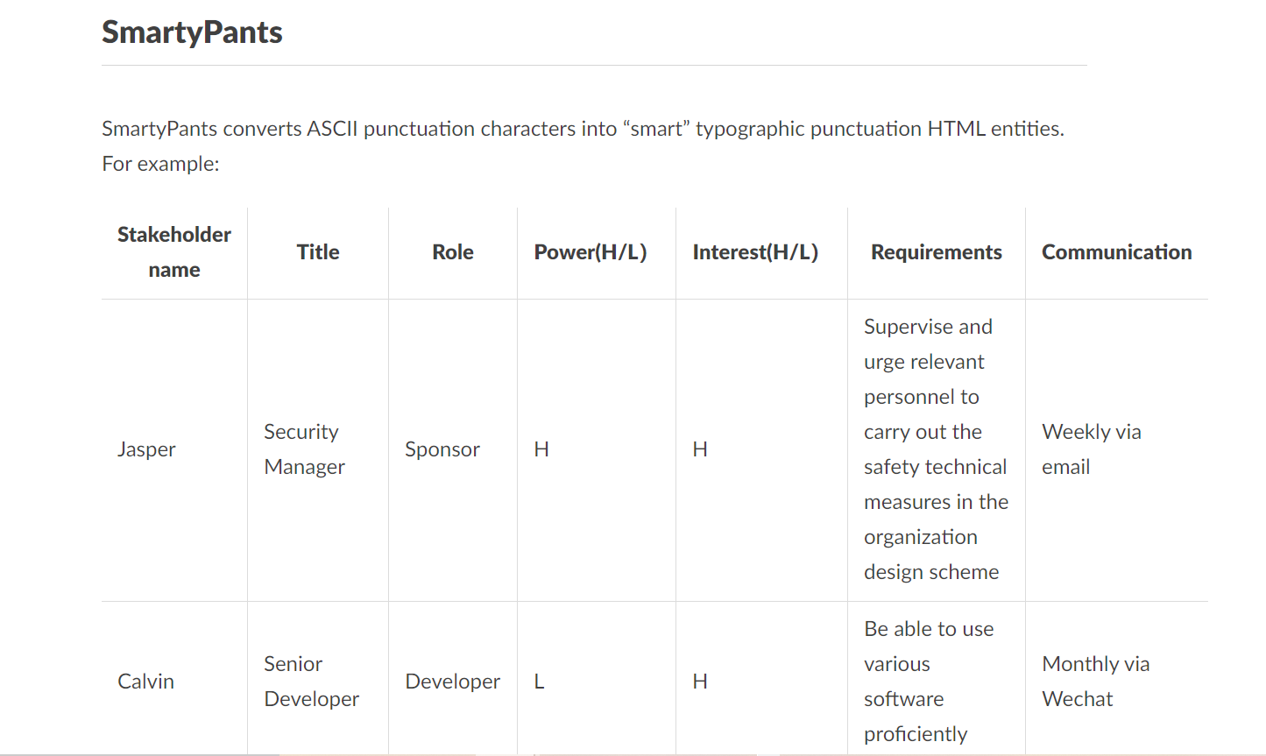

Yam Yam and Ron are responsible for collecting information.

Tracy and Flossie are responsible for sorting datas and summarizing.

On week2,we had completed Lab 2 - Working on Repository Git and refer to resource links below to read about user personas.

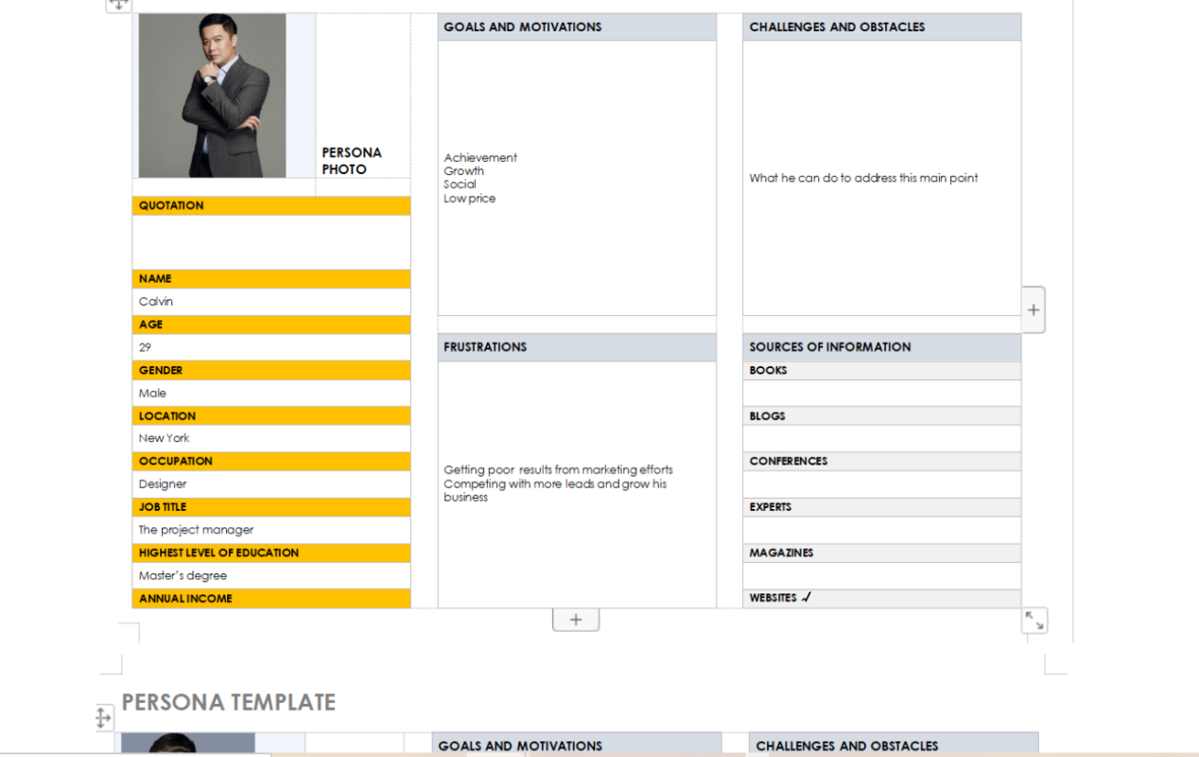

Tracy and Flossie worked on Persona development.

Yam Yam and Ron worked on Persona testing and review.

We all do many efforts for these task.

Staging area commands and Repository Area - COMMIT

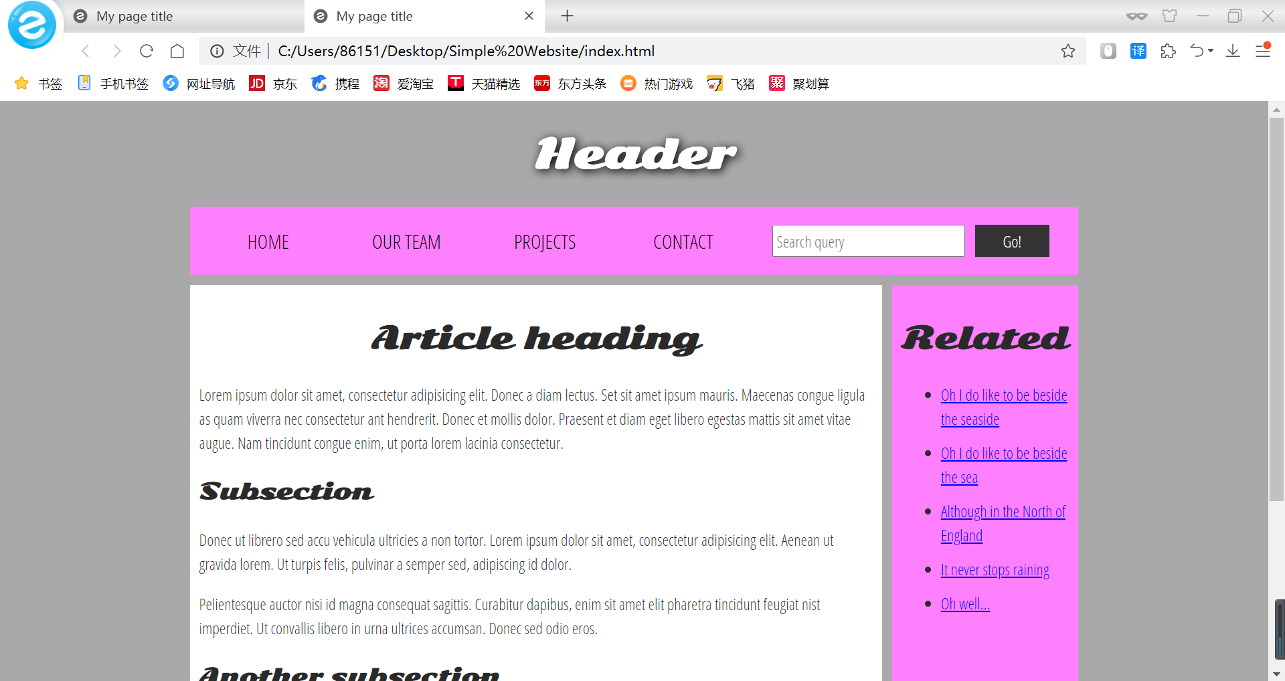

On week3,we are working on branches & merges - Git.In order to Describe the main objectives of working on Git branches and merges.

2.Provide feedback about what’s working, what’s not working, and what your group needs to improve on as you prepare for Iteration 2.

It is not effective to talk about tasks that are unclear and without goals.Discussion group members' general work content, work objectives, and detailed division of labor is effective.

Add a review between listening and dialogue. In the review, repeatedly emphasize restraint. You should restrain your own emotions and sort out the emotions of the other party. In conversation, humor and empathy can make communication smooth.

We need to improve the efficiency of our development schedule.Everyone should follow the conventions for branch naming, tagging, and encoding.